Q.How get remotely Access of instance on linux by ssh ?

🡺 step 1:- Firstly go to linux and get download aws cli installation on it.

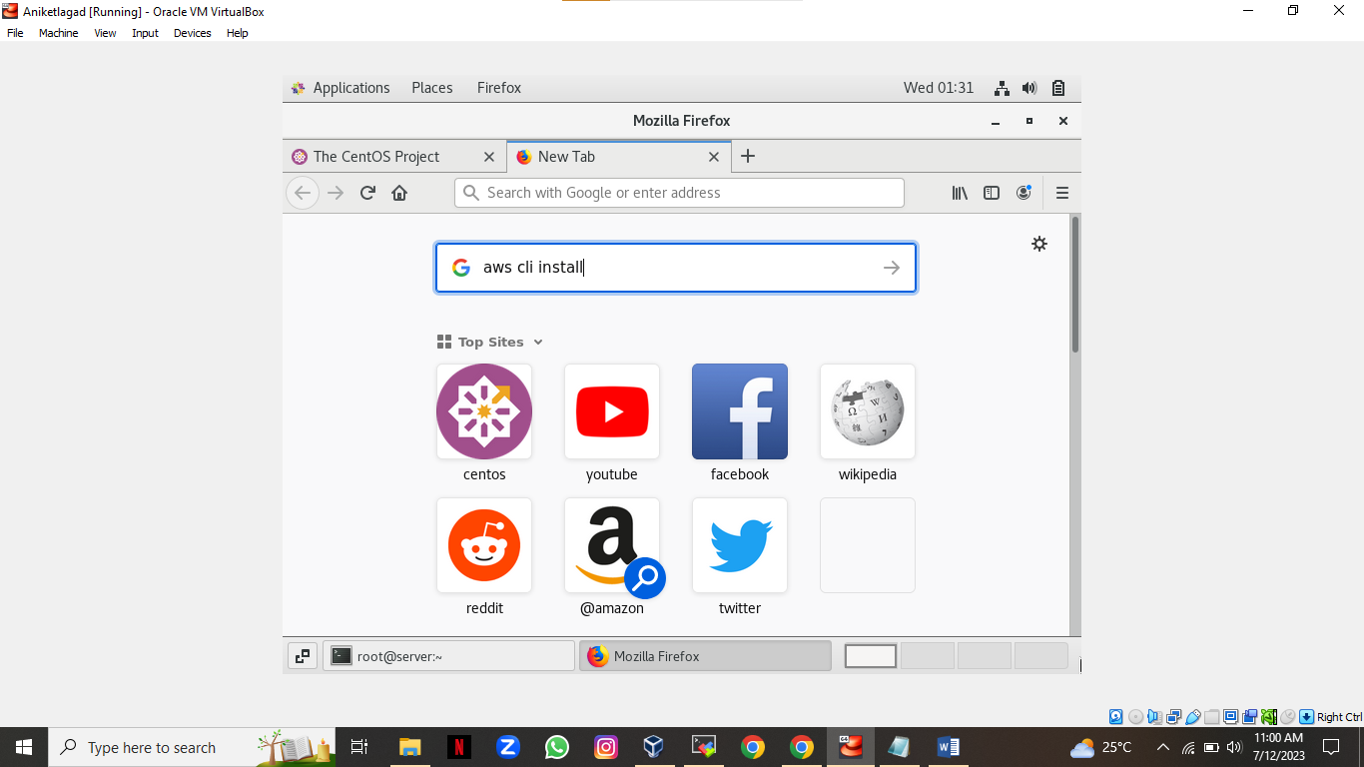

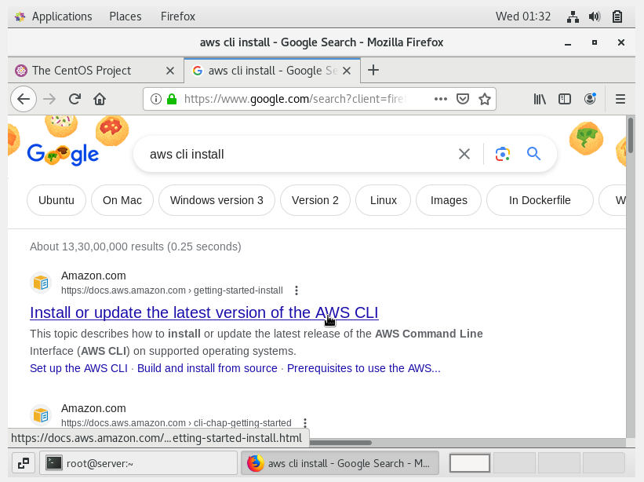

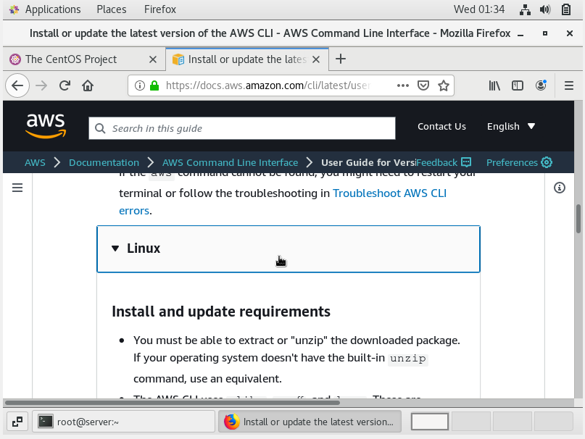

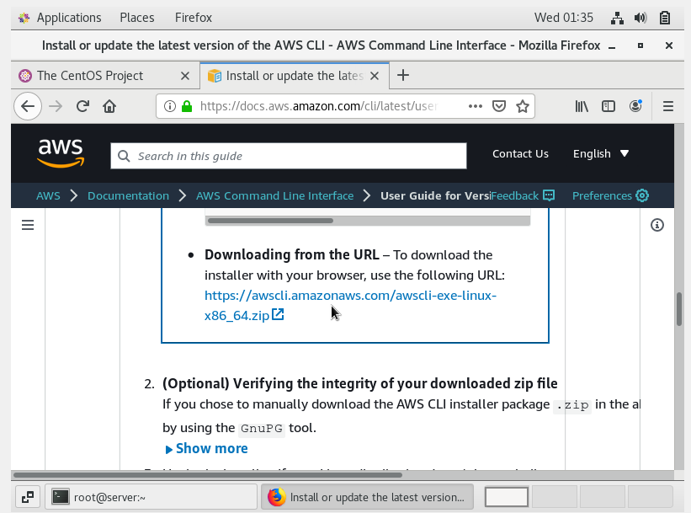

Step 2:- after download completed then go to linux get that machine’s access on moboxtrem.

Step 3:- when u go to moboxterm app then type command cd /root/Download and type command ls and u will see a package of aws in archive format so extract it in normal file and then install it.i will show following it install.

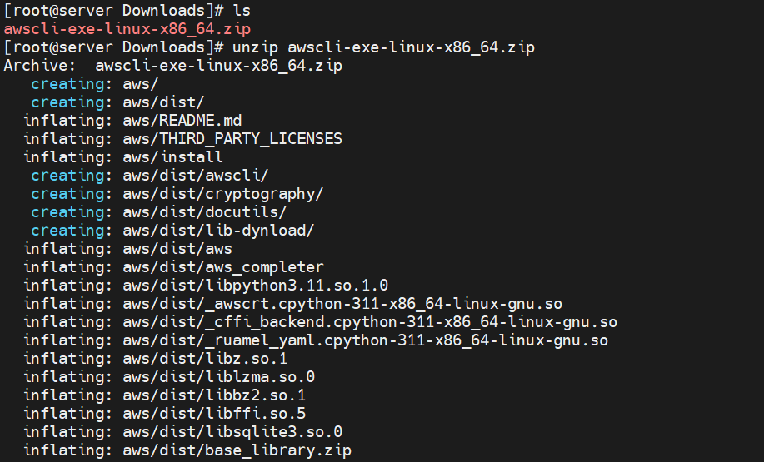

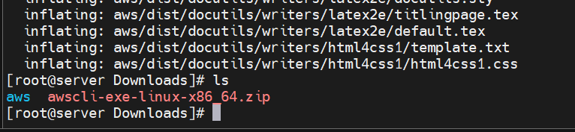

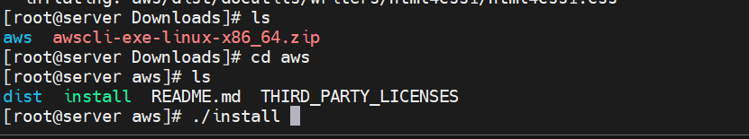

Step 4:-After that configure aws with help of user’s access key and secret key of aws in following way.

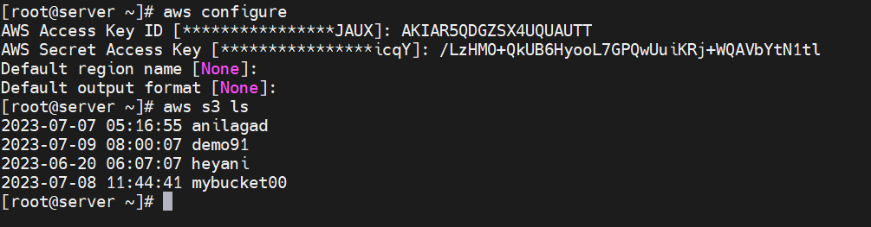

Step 5 :- You have not private key in your linux machine and not working drag and drop process so you will put that key in your aws bucket and then download in linux by aws commands see following steps to process.

NOTE :- For download that private key from bucket to do 1 to 4 step first .

Step 6:-First add your private key in aws bucket make sure that key linked with instance.

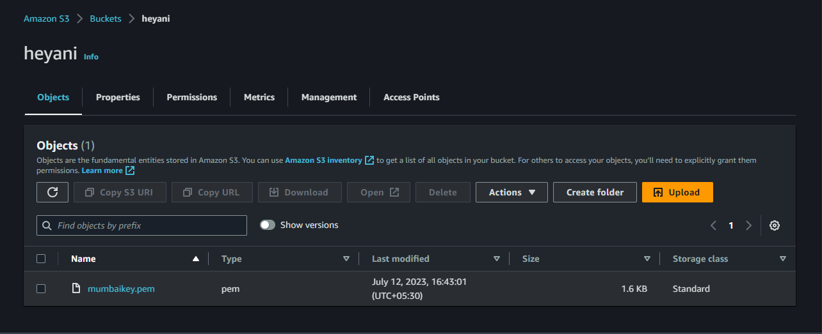

Step 7:- Now Go to moboxtrem and download private key to linux by aws command

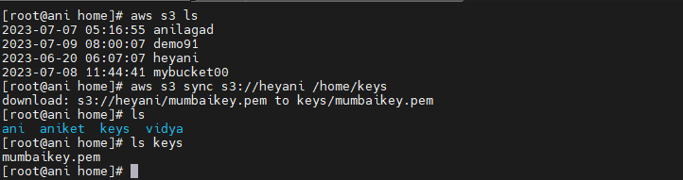

Step 8 :- No go to instace get its public ip for get its remotely access

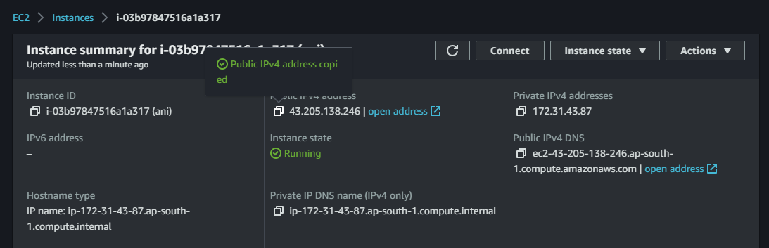

Step 9 :- open moboxtrem and get access by ssh and gave a permission to that key 600.

See following steps to do practical.

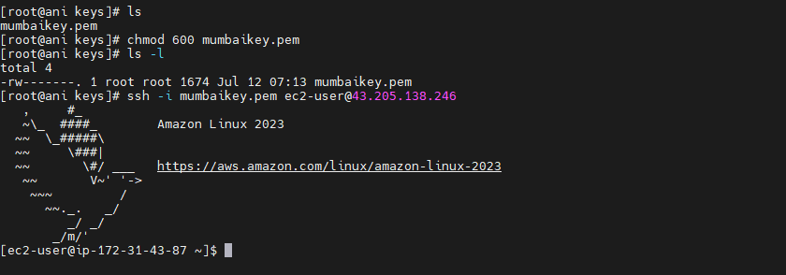

\*\*\*The End\*\*\*